**General Instructions**

1. **Flask Installation**

pip3 install -r requirements.txt

pip3 install Flask

1. **To run**

python3 application.py

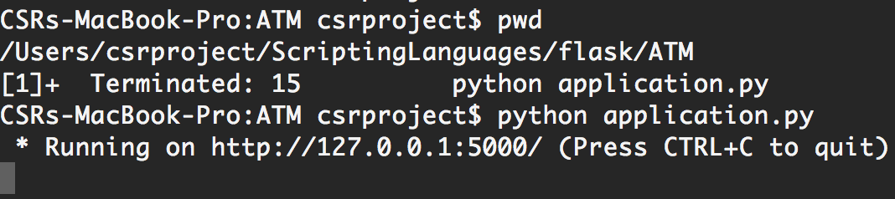

Open 127.0.0.1:5000 in the Browser to get the home screen of the application which will be the .html file mentioned in the render-template method of the “GET” request.

**E.g.** if request.method == "GET":

return render_template("index.html", balance=balance, msg="")

1. **Code** **Explanation**

|  |  |  |
| --- | --- | --- |
| **Sl#** | **Code** | **Description** |
| **1** | app = Flask(__name__)  Used as:  if __name__ == '__main__':  app.run() | name of the program, default built-in variable |
| **2** | @app.route("/", methods=['GET', 'POST']) | / - default route  /usnvalidator - other route (pseudo path )  Refer Stud Reg Program |
| **3** | render_template("index.html", balance=balance, msg="") | Specifies which HTML file in ‘template’ folder to render |
| **4** | redirect(url_for("store")) | Finds the URL associated with a method |
| **5** | **Code in HTML file:**  <a href="{{url_for('cart')}}"> View your Shopping Cart </a> | {{ }}  Is used to include python code in HTML ( Flask uses templating engine - Jinja ) |
| **6** | @app.route("/store", methods=["GET", "POST"]) | GET - render the form  POST - process the form |
|  | Here ‘store’ is just a place-holder. Flask will look for the html files in the 'templates' folder of the 'root' ("/") or the folder from where the python application is run. The IP Address and the port number is visible on the console when the python application is invoked.  If this placeholder is used, then the URL entered in the browser to run this program  must have this placeholder.  Else a HTTP-404 'Not Found' error is displayed.  Correct Usage in browser: http://127.0.0.1:5000/cart | |
| **7** | python3 application.py | ‘application’ is **not** a keyword. It could be any user defined name with .py extension.   * Run in the terminal the command python3 application.py * At the terminal the URL is displayed - IP Address and Port Number where Flask with this python code, is listening to HTTP Requests * Open the browser and copy-paste this URL from the terminal. **Note**: Check 'approutes' in python code to see if URL Placeholder is used * Correct Usage in browser: * If URL Placeholder is used: http://127.0.0.1:5000/store * If URL Placeholder is not used: http://127.0.0.1:5000/ |
| **8** | **In application.py**  @app.route("/store", methods=["GET", "POST"])  def store():  if request.method == "GET":  return render_template  ("store.html") | * Since it is a GET request, the store.html is loaded |
| **9** | **In store.html**  **<form action** = "{{url_for(**'store'**)}}" method="POST">  <input name = "eggs" type = "number" min="0" value="0"/>Eggs - Rs.5 <br>  <input value = "Add to Cart" type = "**submit**"/>  **</form>**  **In application.py**  def **store()**:  if request.method == "POST":  #Write the application logic | * The HTML's Submit button has a FORM ACTION tag that directs it to the Python function (here ‘**store’**) inside the python application run. * This is the portion that **“connects”** HTML-Javascript (Client-Side) and Python (Server-Side) |

1. **Possible Errors and How to Solve**

|  |  |  |
| --- | --- | --- |
| **Sl#** | **Error** | |
| **1** | **“Address Already in Use”**    **Reason**: There is already a python application run on the same IP Address and Port. Here 5000.  **Solution**: $ kill <process id> | |
| **2** | **“Error 500 - Internal Server Error”**  Many Possibilities for this Error   1. **Possibility #1: “templates” or “Templates” is the name of the folder - not “template” or any other name**  * **Error at the browser**      * **Error at the terminal**      |  |  | | --- | --- | | **In-Correct** Folder Structure | **In-Correct** Folder Structure | | |
|  | |  |  | | --- | --- | | **Correct** Folder Structure | **Correct** Folder Structure |  * **At the Terminal - Correct Response Code “200”** | |
|  | **“Error 500 - Internal Server Error”**   1. **Possibility #2: Correct file not present in “templates” folder of flask**  |  |  | | --- | --- | | **In-Correct** File : “Indexx.html” | **Correct** File “**I**ndex.html” or “**i**ndex.html”  (Not Case Sensitive) |   **(OR)**  FIle not present in the “template” folder when asked to be rendered   * **Error at the terminal**      |  |  | | --- | --- | |  | **In ShoppingCart.py**  return render_template("bill.html", cart=cart, amount=amount)  “Bill.html: is not present in ShoppingCart “templates” folder but under ATM “templates” folder. | | |
| **3** | **“Error 404 - Not Found”**   * **Error at the browser**        * **Error at the terminal**     **Reason**: Cannot Locate the Path to the file to be rendered   1. @app.route("/ATM", methods=["GET", "POST"])   The application path specified to have the placeholder “/ATM” while at the browser we type <http://127.0.0.1:5000>  **Solution**: Type the placeholder <http://127.0.0.1:5000>//ATM | |